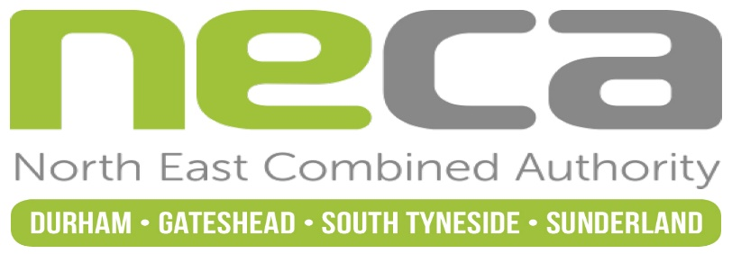

Leadership Board, 1 February 2022
Decisions - Notification
Please Note: In accordance with the Constitution of the Combined Authority, key decisions will not be implemented pending any call-in.
Date of Publication: 4 February 2022
Any valid requests for call-in must be received by the Monitoring Officer by 5pm on Friday 11 February 2022
Agenda item | Decision | Contact Officer
3. Minutes of the previous meeting | Approved as a correct record. | Toby Ord  Strategy and Democratic Services Assistant  toby.ord@northeastca.gov.uk
4. Announcements from the Chair and/or Head of Paid Service | That the announcements be noted. | Beverley Poulter  Lead Policy Officer  Beverley.poulter@sunderland.gov.uk
5. Chair’s Update | That the update be noted. | Beverley Poulter  Lead Policy Officer  Beverley.poulter@sunderland.gov.uk
6. Economic Development and Digital Thematic Portfolio Update | That the update be noted. | Rory Sherwood-Parkin  Senior Economic Policy Manager  rory.sherwood-parkin@southtyneside.gov.uk
7. Transport Thematic Portfolio Update | That the update be noted. | Stuart Corker  Transport Planning Team Leader  stuartcorker@gateshead.gov.uk
8. Audit Completion Report | That the report be noted. | Eleanor Goodman  Finance Manager  eleanor.goodman@northeastca.gov.uk
9. Capital Programme and Treasury Management Policy And Strategy | That (a) the report be noted, (b) it be agreed to administer the capital programme approved by the JTC as set out in section 2.2, (c) that the Treasury Management Strategy and the Treasury Prudential Indicators contained within Appendix 2, including the Authorised Limit be agreed, and (d) the Cash Investment Strategy 2022/23 contained in the Treasury Management Strategy within Appendix 2 be agreed | Eleanor Goodman  Finance Manager  Eleanor.goodman@northeastca.gov.uk
10. Budget 2022/23 and Medium-Term Financial Strategy | That (a) the report be noted, (b) it be unanimously agreed a budget for 2022/23 for the corporate costs of NECA of £0.123m, with an equal contribution of £25,000 from each of the constituent authorities in NECA to help meet these costs, as set out in section 2.7, (c) it be unanimously agreed a budget for 2022/23 in respect of the accountable body role for the JTC in 2022/23 of £0.090m, with equal contributions of £10,000 from the seven local authorities in the JTC area to help meet these costs, as set out in section 2.7, (d) issue the levies as determined by the JTC on its meeting on 2 February 2022, (e) arrangements be made to administer payment of a transport revenue grant to Durham County Council for the delivery of transport services in the Durham area and to Nexus for the delivery of transport services in Tyne and Wear as determined by the JTC on its meeting on 2 February 2022, (f) it be noted that the North of Tyne Combined Authority will issue the Transport levies to Newcastle City Council, North Tyneside Council and Northumberland County Council that have been agreed to the JTC and will pass the levy income from Newcastle City Council and North Tyneside Council to NECA in order to meet costs relating to the Tyne and Wear area, (g) it be noted that the North of Tyne Combined Authority will issue the transport revenue grant to Northumberland County Council agreed by the JTC and make a £10,000 contribution to NECA in respect of Northumberland County Council’s contribution to the costs of the JTC and (h) the Chief Finance Officer and the Monitoring Officer taking such other steps as are necessary to give effect to the proposals in this report be authorised. | Eleanor Goodman  Finance Manager  Eleanor.goodman@northeastca.gov.uk
11. Statement of Accounts | That (a) the report be noted, (b) the Chief Finance Officer signing the Letter of Representation on behalf of the Authority be authorised, (c) the Statement of Accounts for 2020/21 be approved, (d) the Chair of the Leadership Board and the Chief Finance Officer making any further adjustments required to the Statement of Accounts as a result of the conclusion of the external audit and to sign the Statement of Accounts for 2020/21 be authorised, (e) the Annual Governance Statement be approved and (f) the Chair of the Leadership Board and the Head of Paid Service signing the Annual Governance Statement be authorised. | Eleanor Goodman  Finance Manager  Eleanor.goodman@northeastca.gov.uk
12. Date and Time of Next Meeting | 1 March 2022, 2.00pm – noted. | Toby Ord  Strategy and Democratic Services Assistant  toby.ord@northeastca.gov.uk

